**The Chinese Navy Will Be Bigger Than Americas By 2020**

[Kris Osborn](http://www.businessinsider.com/china-wants-350-ships-by-2020-2014-12), [Military.com](http://www.military.com/) (Dec. 13, 2014, 10:34 AM)

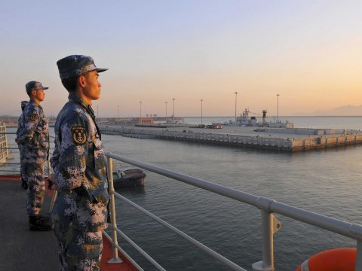

Reuters:

Chinese naval soldiers stand guard on China's first aircraft carrier Liaoning, as it travels towards a military base in Sanya, Hainan province.

China has plans to grow its navy to 351 ships by 2020 as the Chinese continue to develop their military’s ability to strike global targets, according to a new report.

The 2014 US-China Economic and Security Review Commission recommended to Congress the US Navy respond by building more ships and increase its presence in the Pacific region – a strategy they US military has already started.

The commission asked Congress to increase its Pacific fleet up to 67 ships and rebalance homeports such that 60-percent of the force is based in the region by 2020.

The commission's recommendations, which are based on Congressional testimony, expert assessments and open-source information on China’s military and US-Chinese relations, are consistent with Pentagon’s stated plans for the region.

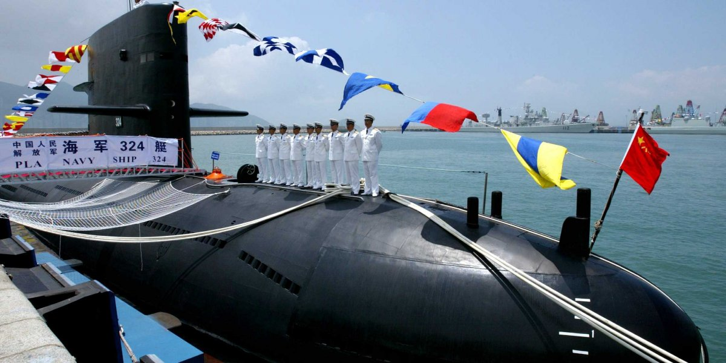

The Navy’s intended Pacific rebalance is designed to station 60-percent of the fleet in the area, rotate more ships and sailors through Pacific ports and move Marine Corps units through Darwin, Australia. Part of the Navy’s Pacific rebalance strategy includes plans to rotate up to four Littoral Combat Ships through Singapore, among other things.

Defense analysts have questioned where the US Navy has the resources and funding to expand its presence in the Pacific adequately enough to meet the emerging Chinese threat. Critics point to the sweeping sequestration cuts as an example of the budgetary challenges that US Navy officials face.

Opponents to this strategy point out that the US has 11 aircraft carriers, the Chinese have one. And that one carrier still lacks an aircraft wing capable of operating off a carrier deck.

The commission cites a platforms and weapons systems the Chinese are developing, which change the strategic calculus regarding how US carriers and surface ships might need to operate in the region. The report mentions the Chinese DF-21D, a precision-guided, land-launched anti-ship ballistic missile designed to reach surface targets at ranges greater than 900 nautical miles.

“China is pursuing a missile-centric strategy with the purpose of holding US aircraft carriers at high risk if they operate in China’s near seas and thereby hinder their access to those waters in the event of a crisis. Given China’s growing navy and the US Navy’s planned decline in the size of its fleet, the balance of power and presence in the region is shifting in China’s favor,” the commission states.

While the commission says the exact amount of Chinese military spending is difficult to identify, China’s projected defense spending for 2014 is cited at $131 billion, approximately 12.2 percent greater than 2013. This figure is about the sixth of what the US spends annually.

Reuters:

A Chinese Naval submarine docks at the Ngong Shuen Chau Naval Base in Hong Kong.

The Chinese defense budget has increased by double digits since 1989, the commission states resulting in annual defense spending doubling since 2008, according to the report.

Rep. Randy Forbes, R-Virginia, chairman of the House Armed Services Committee Seapower and Projection Forces subcommittee, cited the increase in submarine and surface navy patrols tripling since 2007 as an area of concern.

“What they are doing with patrols is just the tip of the iceberg. It is not just the number of the ships, but within five to eight years they will have about 82 submarines in the Asia Pacific area and we will have about 32 to 34,” he said.

“If you look at where we are today, they outnumber us about 60 to 32 in subs. If you look at their surface ships they can get us further out with their anti-ship missiles than we can hit them,” Forbes said.

The Chinese have used cyber espionage of the US military to boost their weapons development programs, the report said. In particular, the review cited a 2012 Defense Science Board report which explains how Chinese cyber spying resulted in their learning details on a number of US systems such as the Littoral Combat Ship, F-35, FA/18, Black Hawk helicopter, Aegis Ballistic Missile Defense, Patriot and Global Hawk.

**Chinese Naval Power**

While Chinese naval technology may still be substantially behind current US platforms, the equation could change dramatically over the next several decades because the Chinese are reportedly working on a handful of high-tech next-generation ships, weapons and naval platforms.

These include the LUYANG III, a new class of Chinese destroyer slated to enter the fleet this year. The ship is being engineered with vertically-launched, long-range anti-ship cruise missiles, the commission said. The new destroyer will carry an extended-range variant of the HHQ-9 surface-to-air missile, among other weapons, the report says.

Furthermore, the Chinese may already be beginning construction on several of their own indigenous aircraft carriers. China currently has one carrier, the Ukranian-built Liaoning. It is not expected to have an operational carrier air wing until at least 2016, according to the report.

The Chinese are currently testing and developing a new, carrier-based fighter aircraft called the J-15.

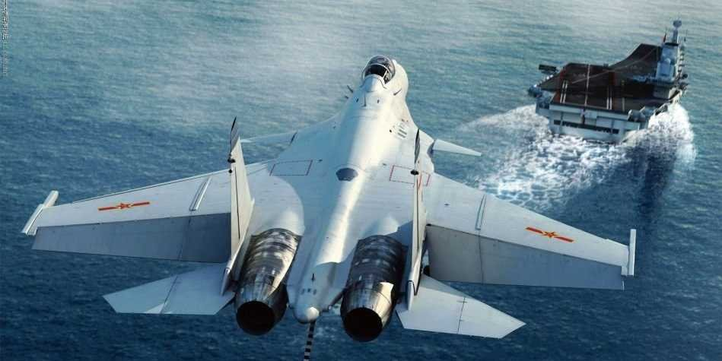

[Sina](http://blog.usnavyseals.com/2012/11/uss-nimitz-encounters-mechanical-problem-leaving-the-u-s-navy-understaffed-in-the-persian-gulf.html)A promotional poster of a J-15 landing on an aircraft carrier

Regarding amphibious assault ships, the Chinese are planning to add several more YUZHAO LPDs, amphibs which can carry 800 troops, four helicopters and up to 20 armored vehicles, the report said.

The Chinese are also working on development of a new Type 055 cruiser equipped with land-attack missiles, lasers and rail-gun weapons, according to the review.

“They are becoming a blue-water Navy,” said Larry Wortzel, a commissioner tasked with helping to oversee the compilation and publication of the annual review.

China’s surface fleet is also bolstered by production of at least 60 smaller, fast-moving HOBEI-glass guided missile patrol boats and ongoing deliveries of JIANGDAO light frigates armed with naval guns, torpedoes and anti-ship cruise missiles.

The commission also says Chinese modernization plans call for a sharp increase in attack submarines, nuclear-armed submarines or SSBNs. Chinese SSBNs are now able to patrol with nuclear-armed JL-2 missiles able to strike targets more than 4,500 nautical miles.

The Chinese are currently working on a new, modernized SSBN platform as well as a long-range missile, the JL-3, the commission says.

The commission also specifically addresses areas of Chinese-Russian military developmental cooperation, saying the two countries are working on a joint deal to build new attack submarines.

“China is pursuing joint-design and production of four to six Russian advanced diesel-electric attack submarines containing Russia’s latest submarine sonar, propulsion, and quieting technology. The deal would improve the PLA Navy’s capabilities and assist China’s development of quiet submarines, thus complicating future US efforts to track and counter PLA submarines,” the commission writes.

In addition, China is reportedly pursuing a new class of nuclear submarines, called the Type 095 SSGN, which could bring the country its first-ever submarine-launched, land-attack cruise missile.

Read the original article on [Military.com](http://www.military.com/). Copyright 2014.